**E-Campus Menus**

1. **Masters**

* Academic Year
* Course
* Semester
* Course Semester Mapping
* Subjects
* Course Subject Mapping
* Employee
* Section
* Student Section Mapping
* Faculty Subjects
* Master Grade

1. **Admission**

* Admission Form
* Enquiry Form
* Student Database

1. **Attendance**
2. **Time Table**

* Time Table
* Faculty Time Table Monthly
* Faculty Time Table Weekly

1. **Examination**

* Exam Form Generation
* Exam Time Table
* Exam Attendance
* Exam Result Marks Entry
* Result Exam Subject
* Generate Mark sheet

1. **Reports**

* Student Count By Course Semester Boys and Girls
* Student Count By Course Semester All Category
* Student Admission Admitted
* Student Code and Student Details
* Admission Register
* Section wise Time Table
* Exam Time Table
* Result Subject Wise
* All Subject Result
* Student Attendance
* Exam Attendance
* Mark sheet Reports
* Student Result
* Admission Category Wise

1. **Fees**
2. **Leaves**

**Academic Year**

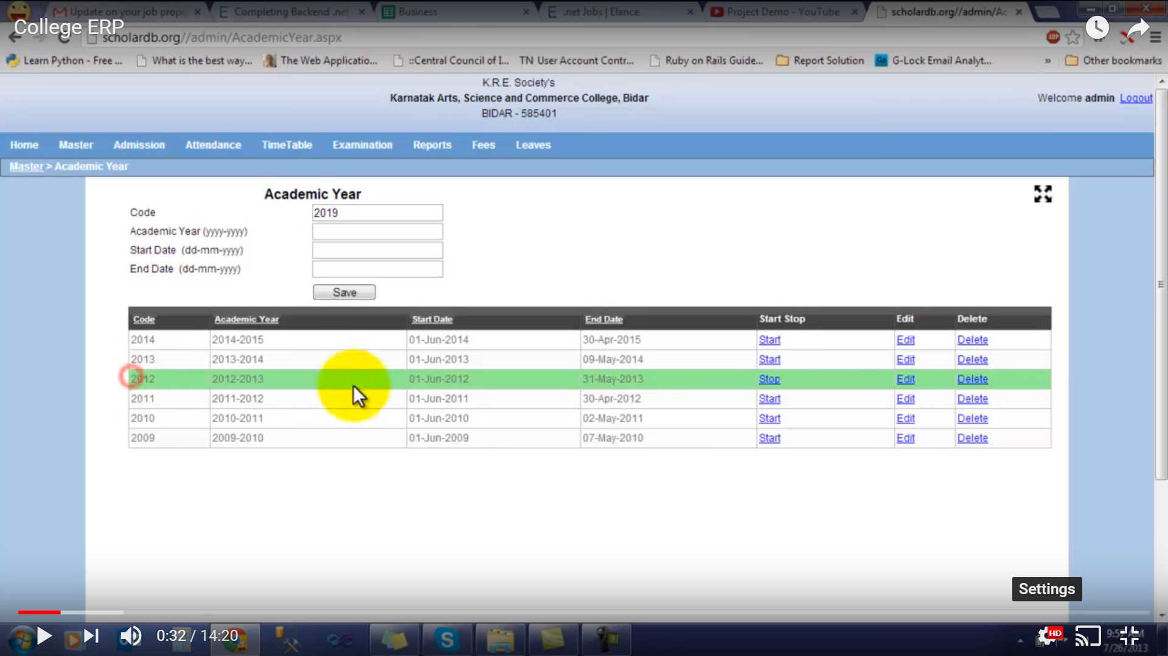

**Course**

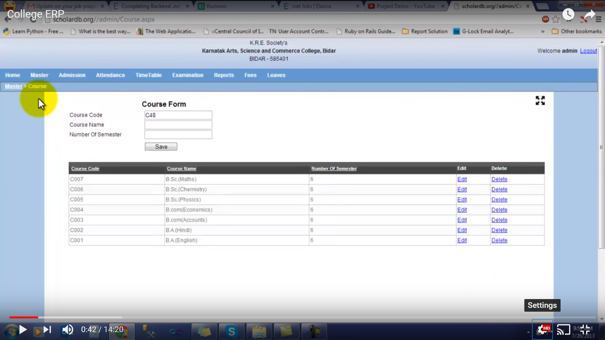

**Course Semester Duration**

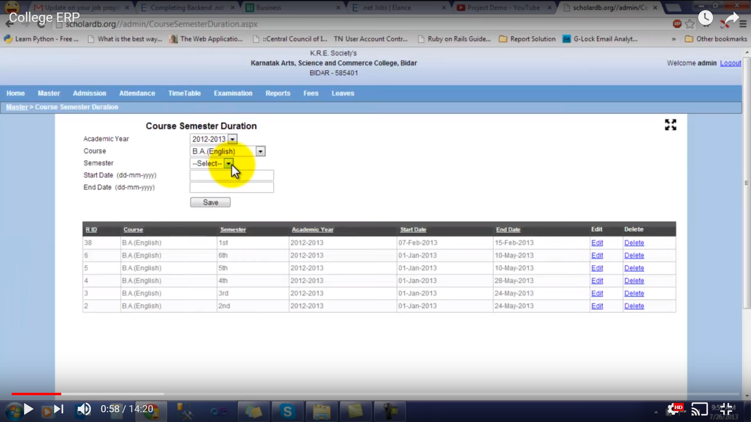

**Activity**

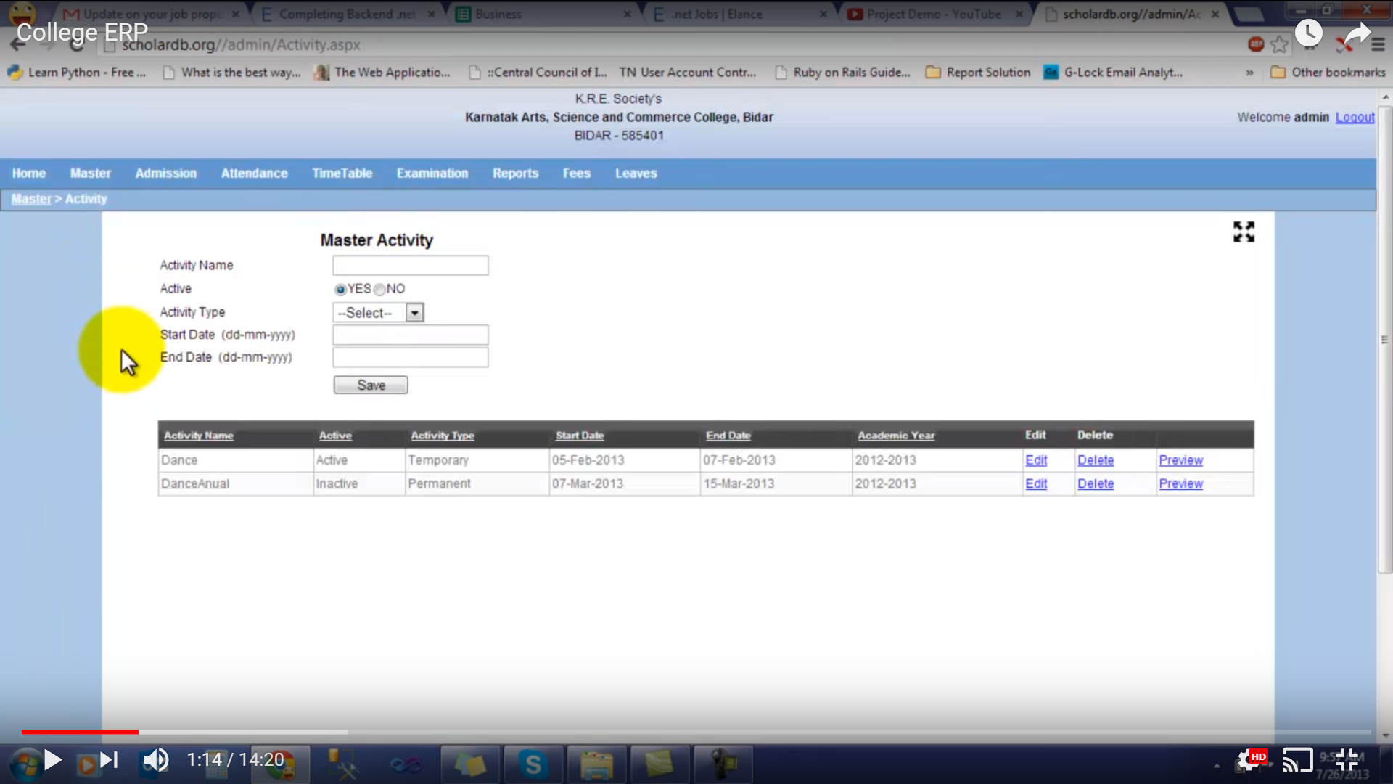

**Activity Fields**

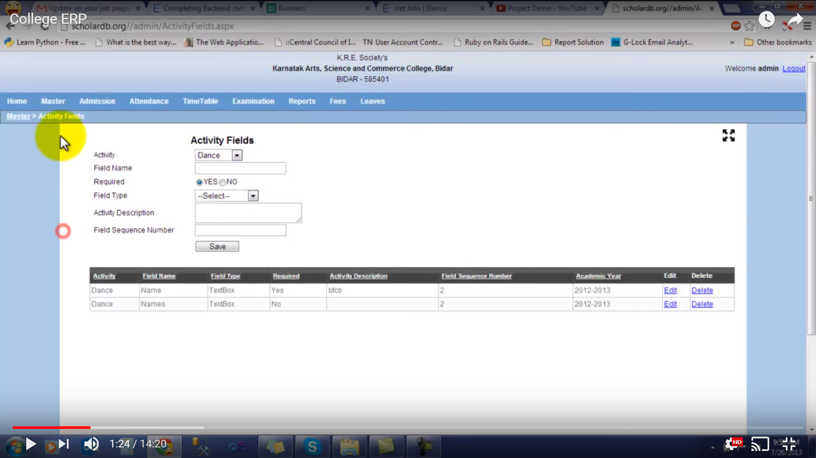

**Subject**

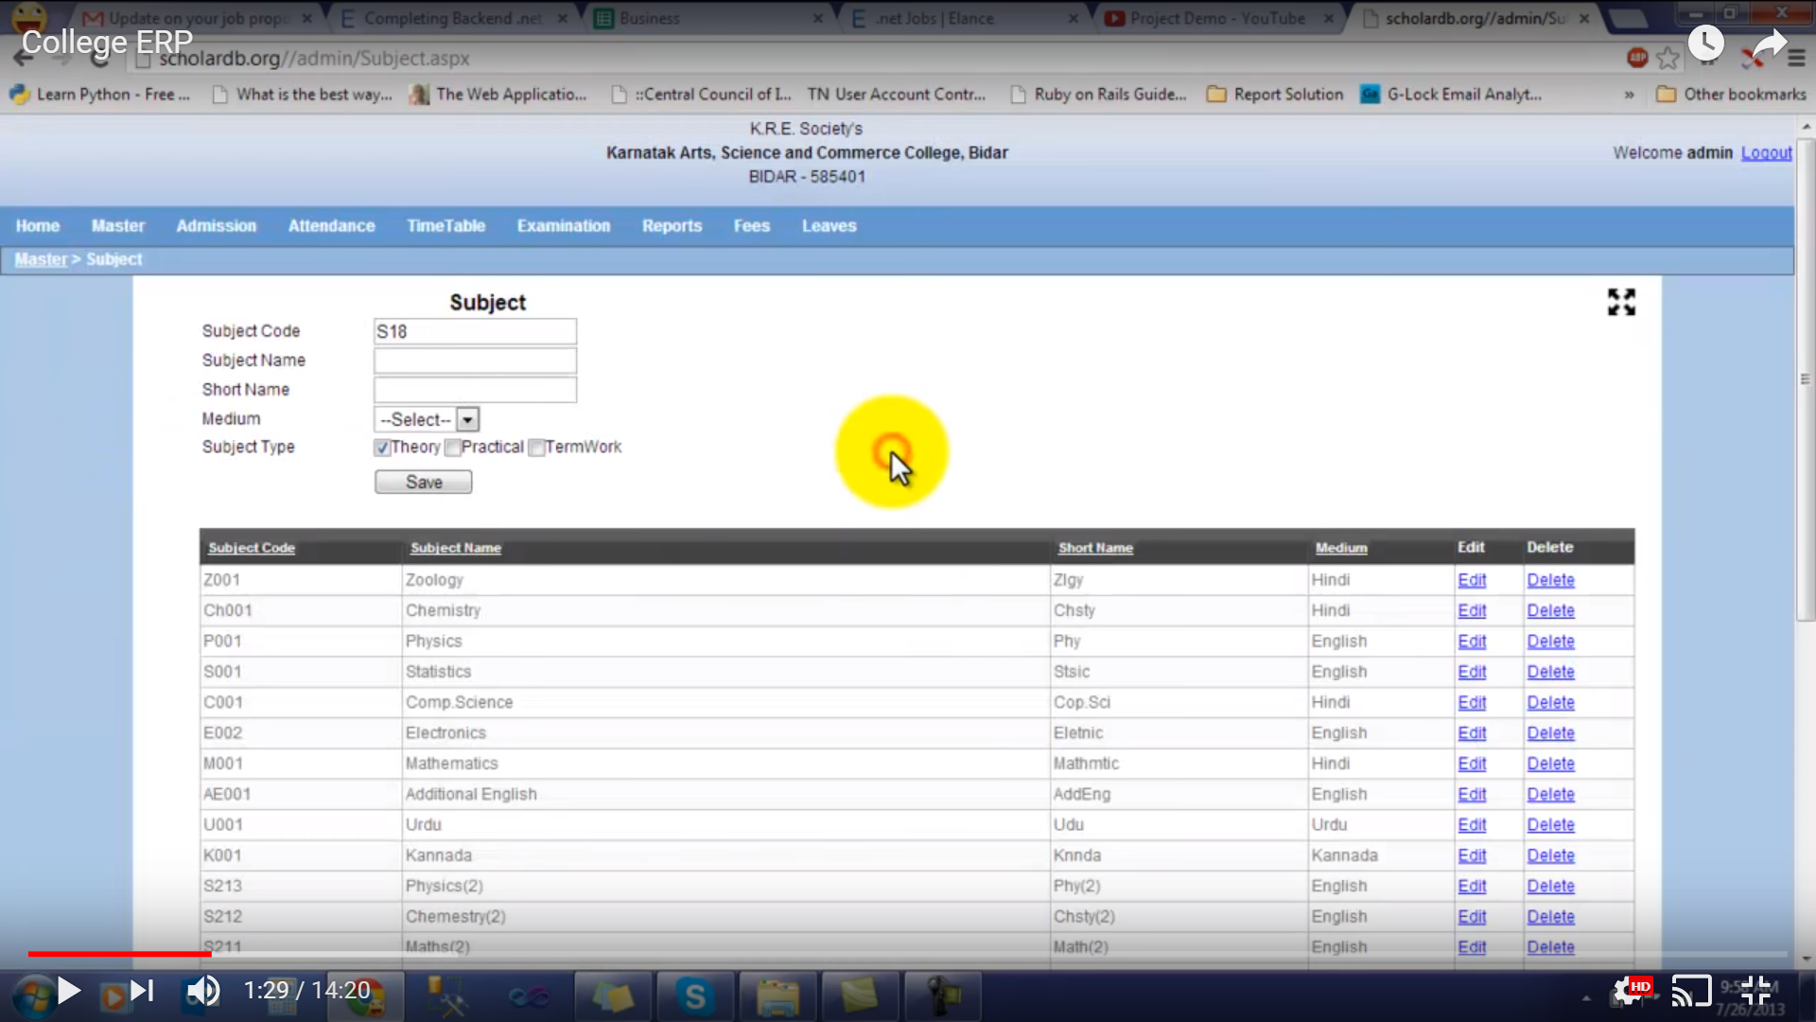

**Course Subject Mapping**

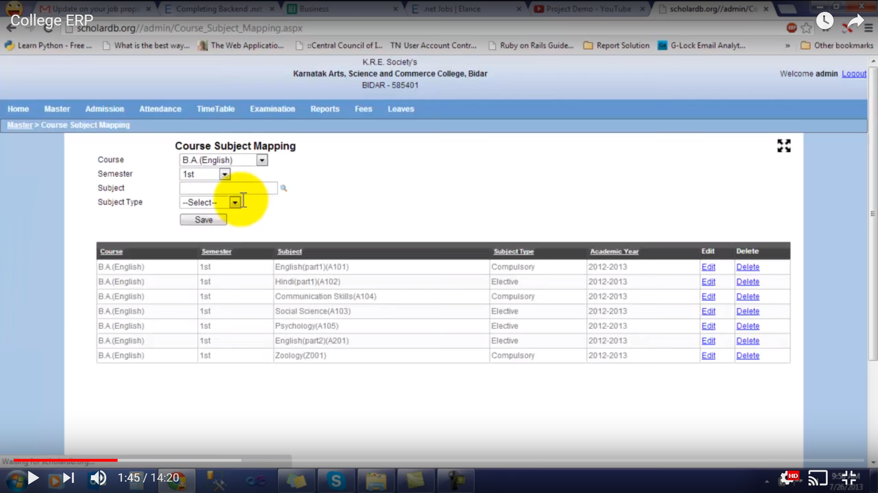

**Employee**

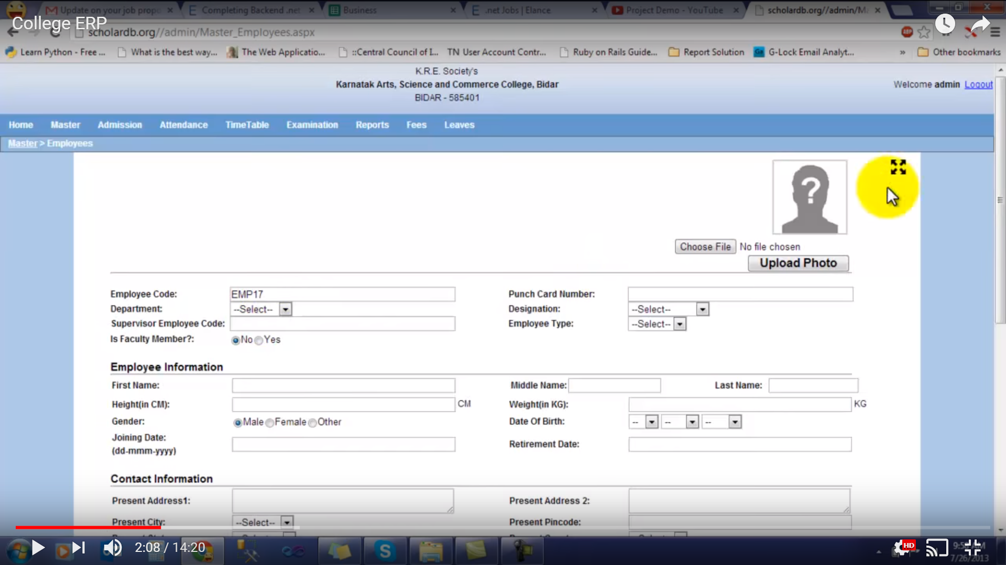

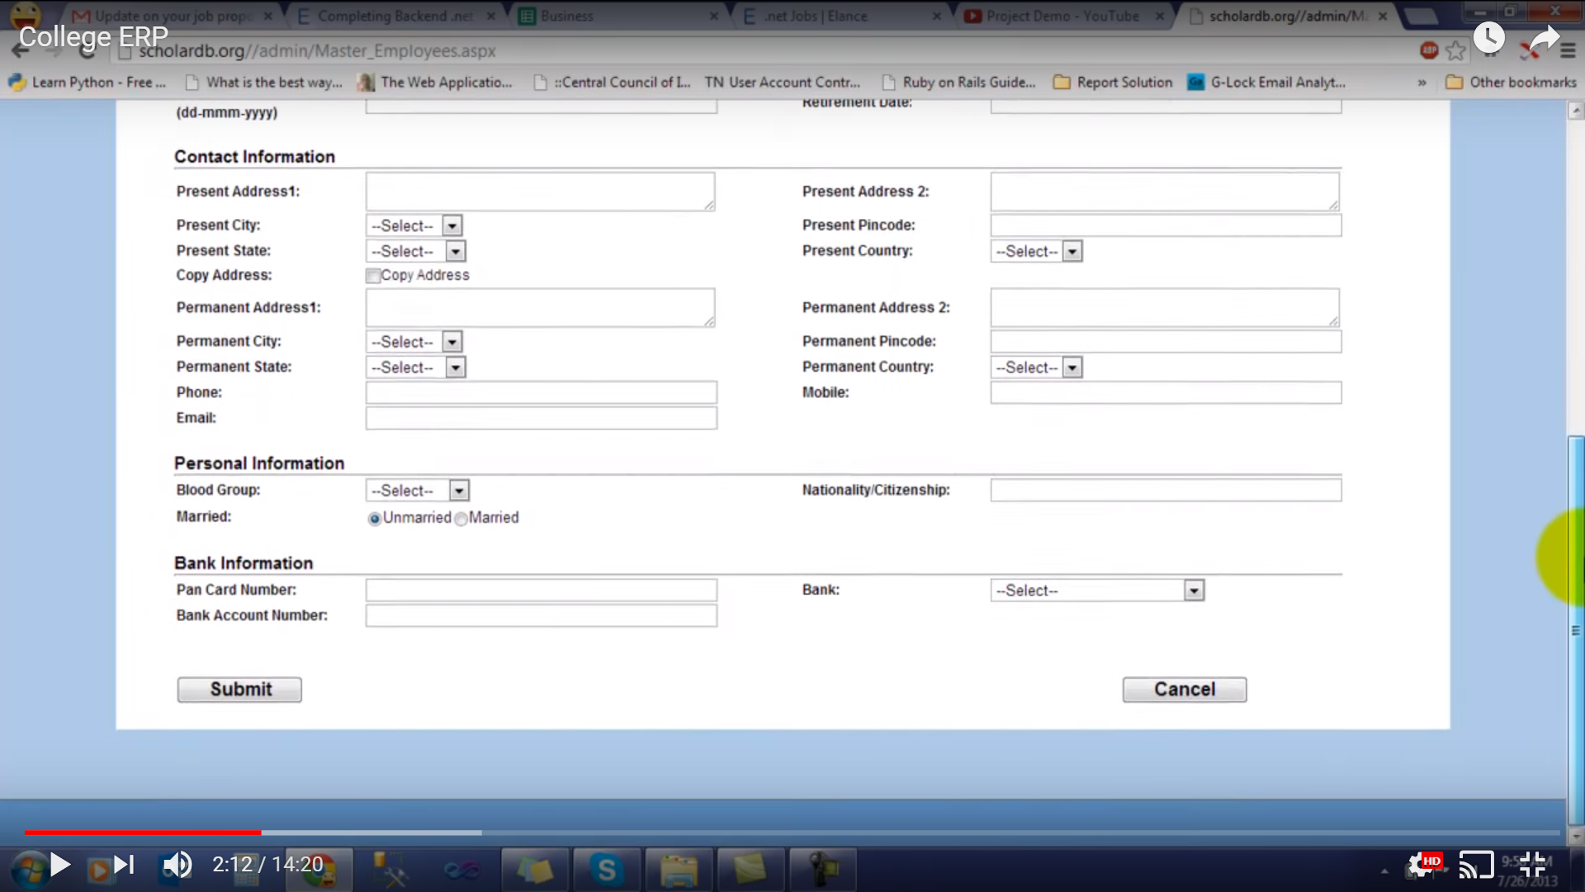

**Employee Search**

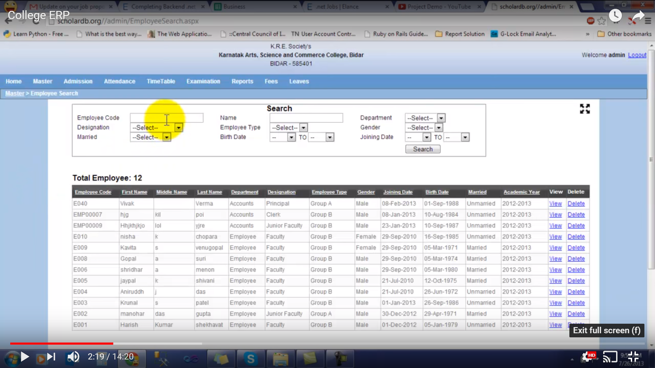

**Section**

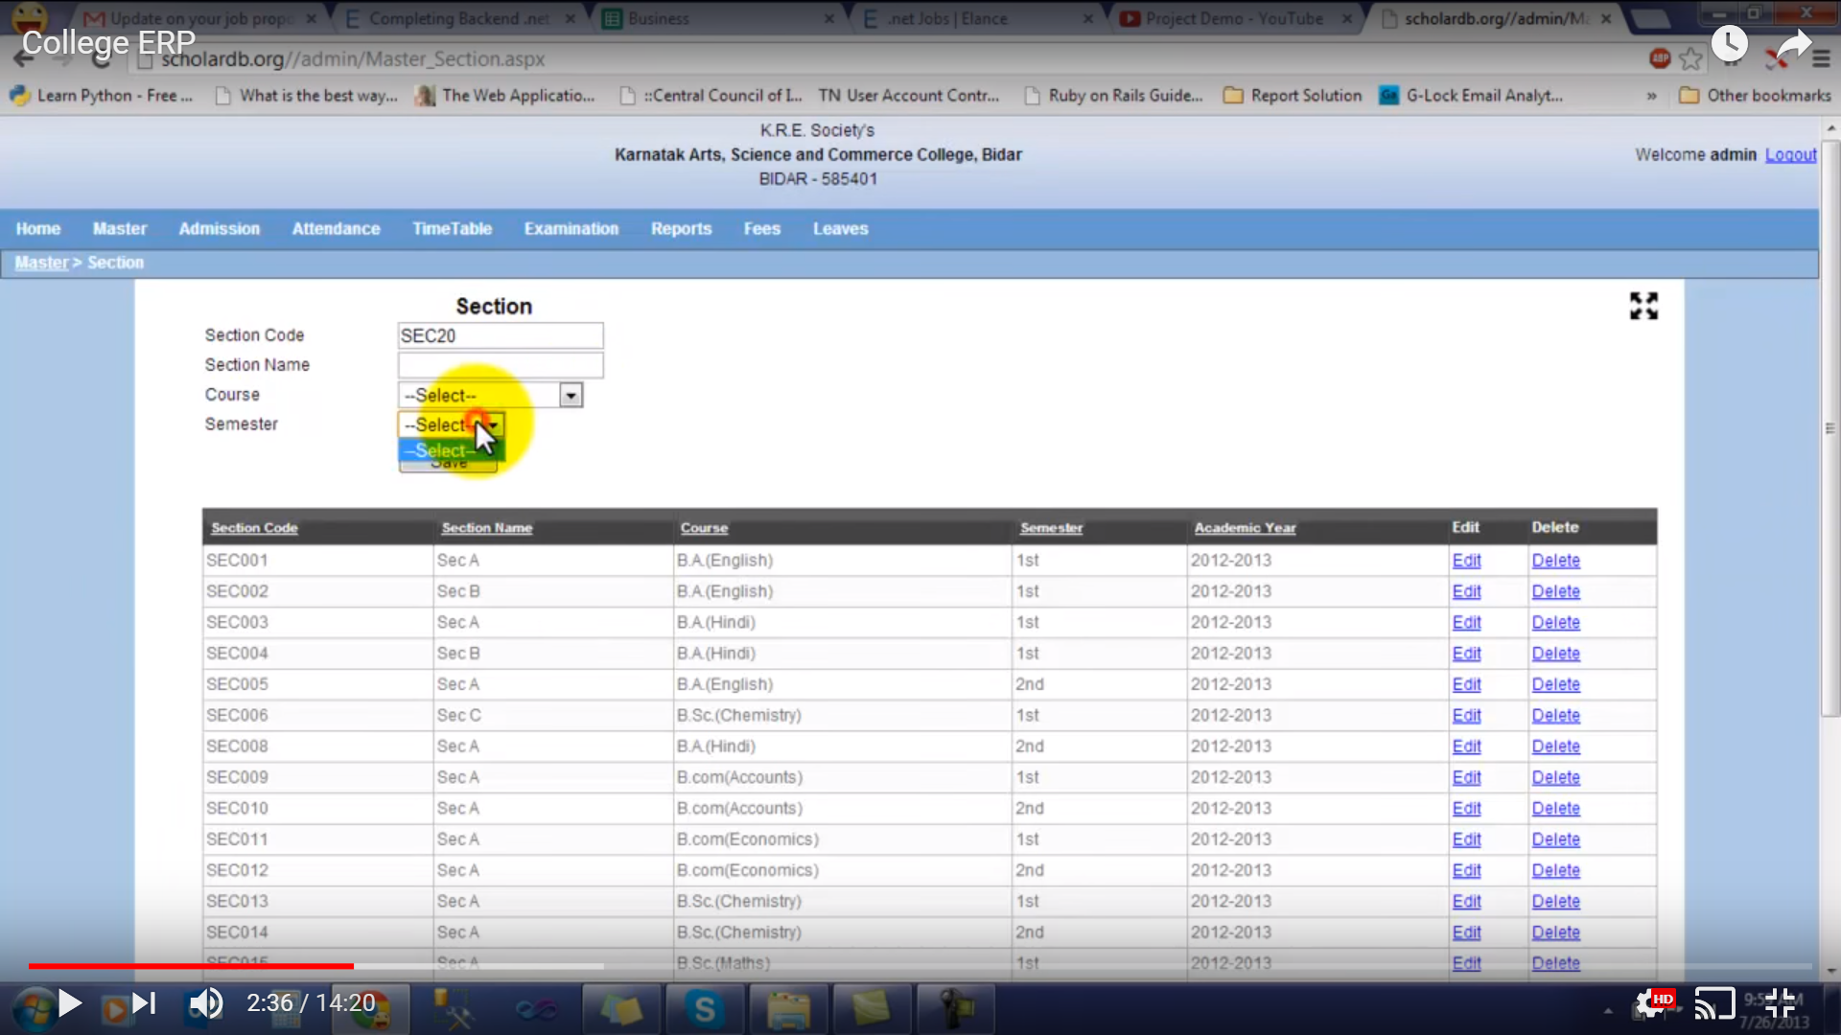

**Faculty Subject**

